**PRACTICAL 9**

AIM: To implement NAT

NAT means network address translation

* Why do we require it?

To convert public ip to private and private to public ip

* What are the benefits of using it?

Practically all device need to connect with internet where public ip is required giving every device to public ip is next to impossible causes numerous cost and increase traffic so we do implement NAT concept.

Lets start with static NAT first Make below type of network

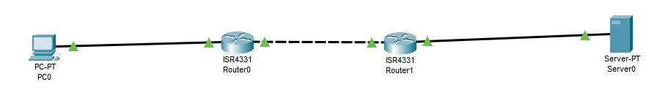

Then do as follow Give ip address to PC0

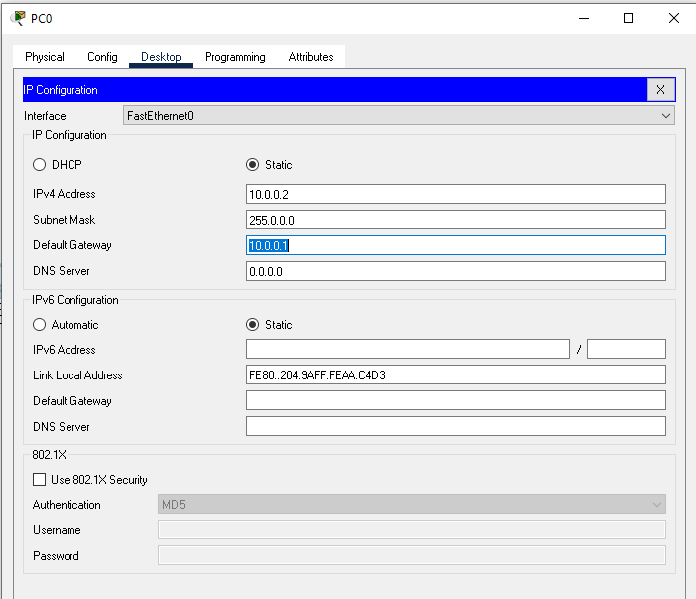

I have created totally 3 networks

* 10.0.0.0
* 20.0.0.0
* 30.0.0.0

So start with pco then give ip address to router1 on both interface 1 interface connected to pc

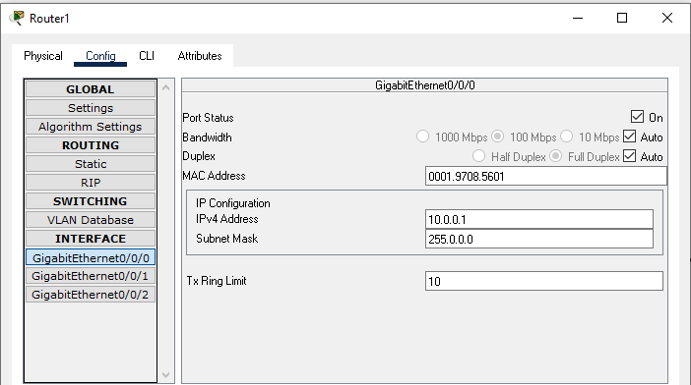

2 interface connected to Router

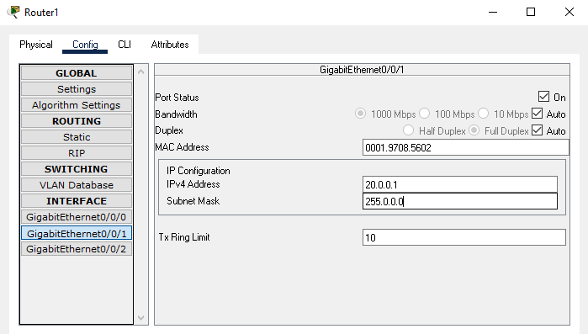

Now similarly configure router1

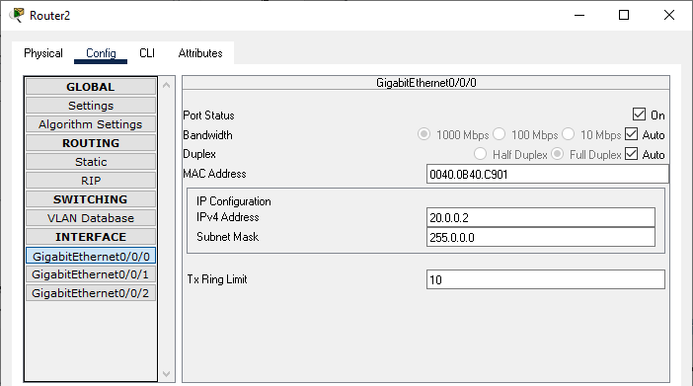

Now the router2 connected to Server ip

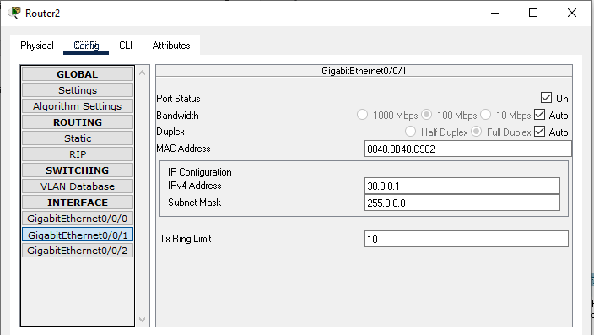

Now server Ip

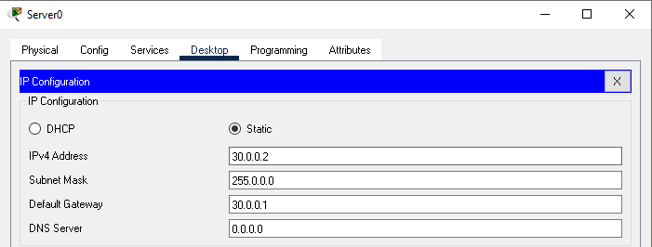

Now add Routing to both routers

Then we do implement NAT and for that use Below commands

* It requires three steps for configuration of Static NAT.

1. Define IP address mapping.
2. Define inside local interface.
3. Define inside global interface.

Router(config)# ip nat inside source static [inside local ip address] [inside global IP address]

Static NAT Configuration on R2.

R1(config)#ip nat inside source static 10.0.0.2 50.50.50.50 R1(config)#interface FastEthernet 0/0

R1(config-if)#ip nat inside R1(config-if)#exit R1(config)#

R1(config)#interface Serial 0/0/0 R1(config-if)#ip nat outside R1(config-if)#exit

Static NAT Configuration on R2.

R2(config)#ip nat inside source static 30.0.0.2 50.50.50.50 R2(config)#interface FastEthernet 0/0

R2(config-if)#ip nat inside R2(config-if)#exit R2(config)#

R2(config)#interface Serial 0/0/0 R2(config-if)#ip nat outside R2(config-if)#exit

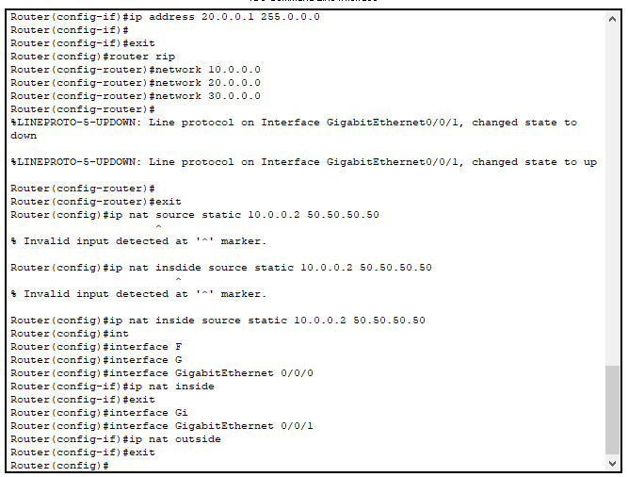

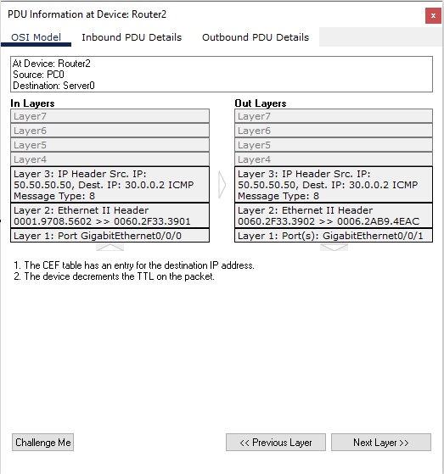

Hence we have given 50.50.50.50 to all as a public ip so it will go out with this ip in the network